Robot Framework with Python and Pycharm Configuration

Contents

1. Install Python 2

2. Install ChromeDriver 6

3. Install Robot Framework and Selenium Library 7

4. Install PyCharm 10

# 1. Install Python

Use the following link - <https://www.python.org/downloads/> to download Python. The current latest version is 3.7.4. Go to the highlighted section and click on **Download** link to select the correct version in terms of operating system.

Below are versions for Python 3.12.3. System type can be found in above screen shots for computer name. For Windows 64-bit Operating System, please download **Windows installer(64-bit)**.

Run the executable file “python-3.12.3-amd64.exe” to install Python. In below popup, please check the box **Add Python 3.12 to PATH** before clicking on **Install Now** option. This step will add all required paths in Environment Variables.

Below Screenshot is having older versions

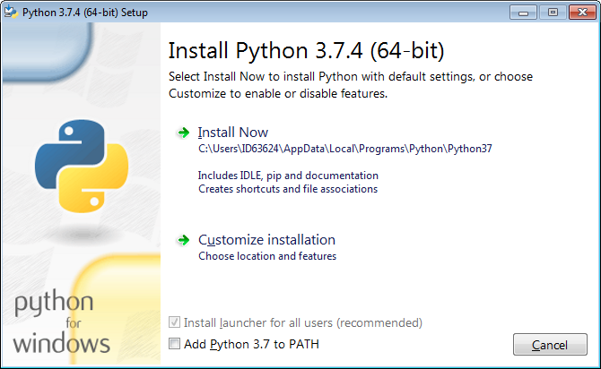

Click on Next Until we can see the Install button.

We need Admin credentials to install this in our machines. So, contact support team through MyTech portal and install this.

In case the **Add Python 3.12 to PATH** check box is not checked during installation, please go to System again and click on “Advanced system settings.”

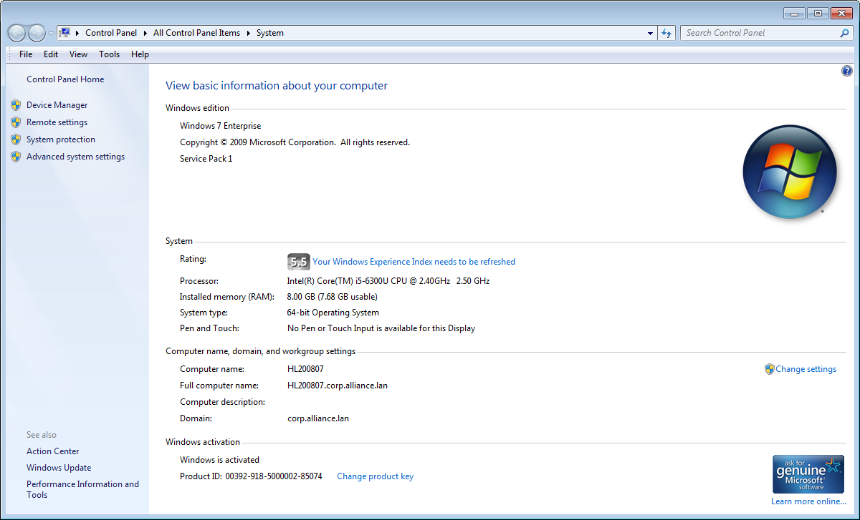

Click on “Environment Variables…”

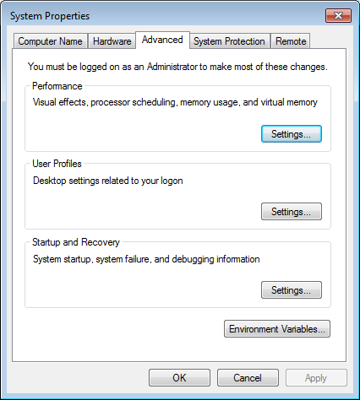

Find the variable “**Path**” in user variables section. Click on “**Edit…**” and add below two paths in Path variable. **The paths can be different based on where Python is installed in your machine.**

Ex:

C:\Users\ID63624\AppData\Local\Programs\Python\Python37\Scripts\

C:\Users\ID63624\AppData\Local\Programs\Python\Python37\

**Note: Paths are required to be separated by semicolon if multiple paths in Path variable.**

If the Path variable is not available in user variables section, click on “New…” to add Path variable and enter path values.

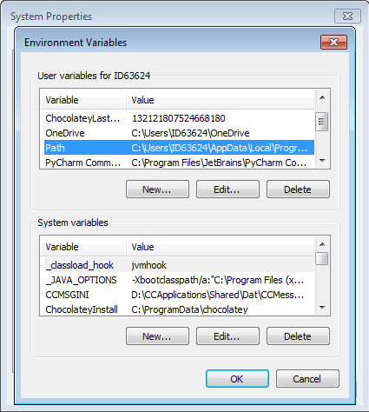

Go to Windows Start Menu -> All Programs -> Accessories and click on **Command Prompt**. In pop screen, enter **python --version** in the command line and hit <Enter>. If the Python is installed properly, the correct version information will be displayed as Python 3.12.3.

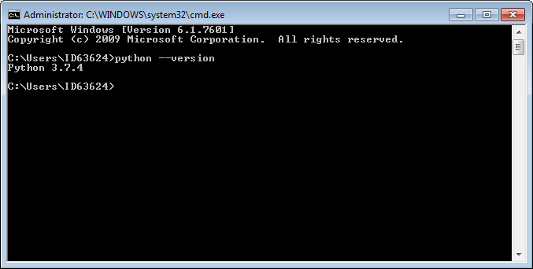

# 2. Install ChromeDriver

Use the following link - <http://chromedriver.chromium.org/downloads> to download ChromeDriver.

For Google Chrome, please check your Chrome browser version through Help -> About Google Chrome

Once it’s downloaded, please keep this file in your local drive and add the folder **path** to Environment Variables. **This path can be different based on where ChromeDriver is stored in your machine.**

Ex:

C:\Users\ID63624\AppData\Local\Programs\Chromedriver

Please find more information related to ChromeDriver in the following link - <http://chromedriver.chromium.org/getting-started>.

# 3. Install Robot Framework and Selenium Library

Go to Tools -> Folder options… -> View and change the Advanced settings for **Hidden files and folders** to **Show hidden files, folders, and drivers**. Then hidden folder C:\ProgramData can be displayed.

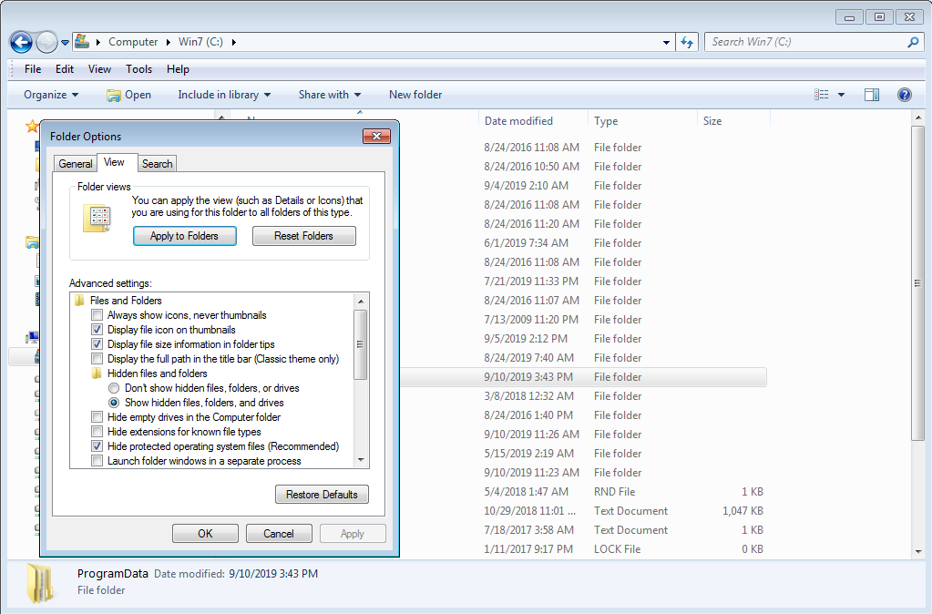

Create a new pip folder under the existing folder **C:\ProgramData** and copy the below file in pip folder.



Go to Command Prompt, enter **pip --version** and hit <Enter> to check if pip command is installed and configured properly.

The current pip version is 23.2.1

Enter **pip install robotframework** and hit <Enter> to install Robot Framework.

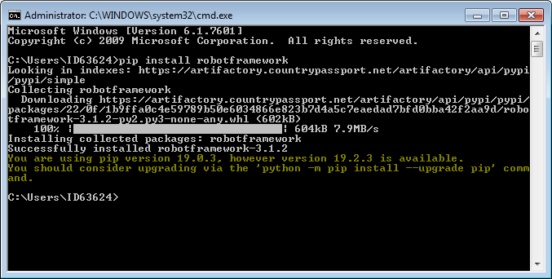

Enter **pip install robotframework-seleniumlibrary** and hit <Enter> to install Robot Framework Selenium Library.

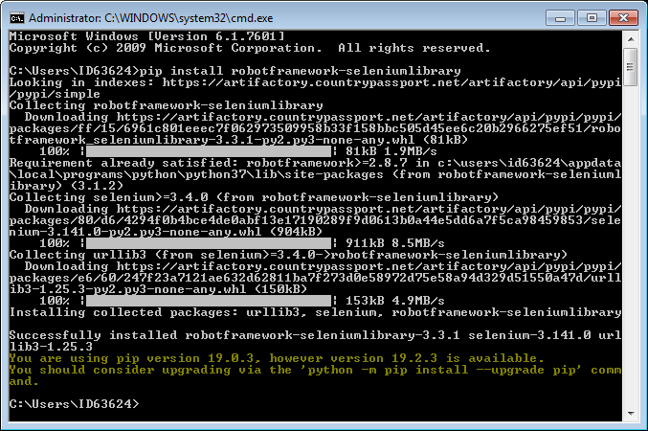

# 4. Install PyCharm

Use the following link - <https://www.jetbrains.com/pycharm/download/#section=windows> to download PyCharm which is one of integrated development environment (IDE) tools for Python and Robot Framework.

Select **Community version** to download. The current version is 2024.1

During PyCharm installation, please check the box for **Add launchers dir to the PATH** and below information will be added into Environment Variables.

**%PyCharm Community Edition%**

Restart your machine after the installation.

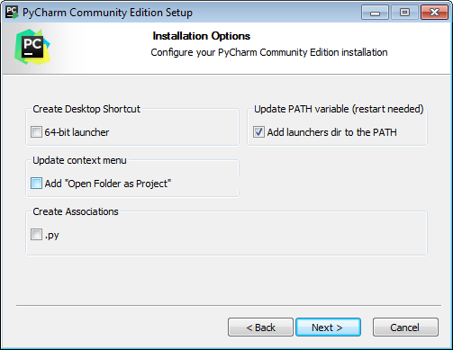

Installation Process needs Admin Credentials. So, contact support team through MyTech portal and Get it installed.

Create a project “TestProject” in PyCharm.

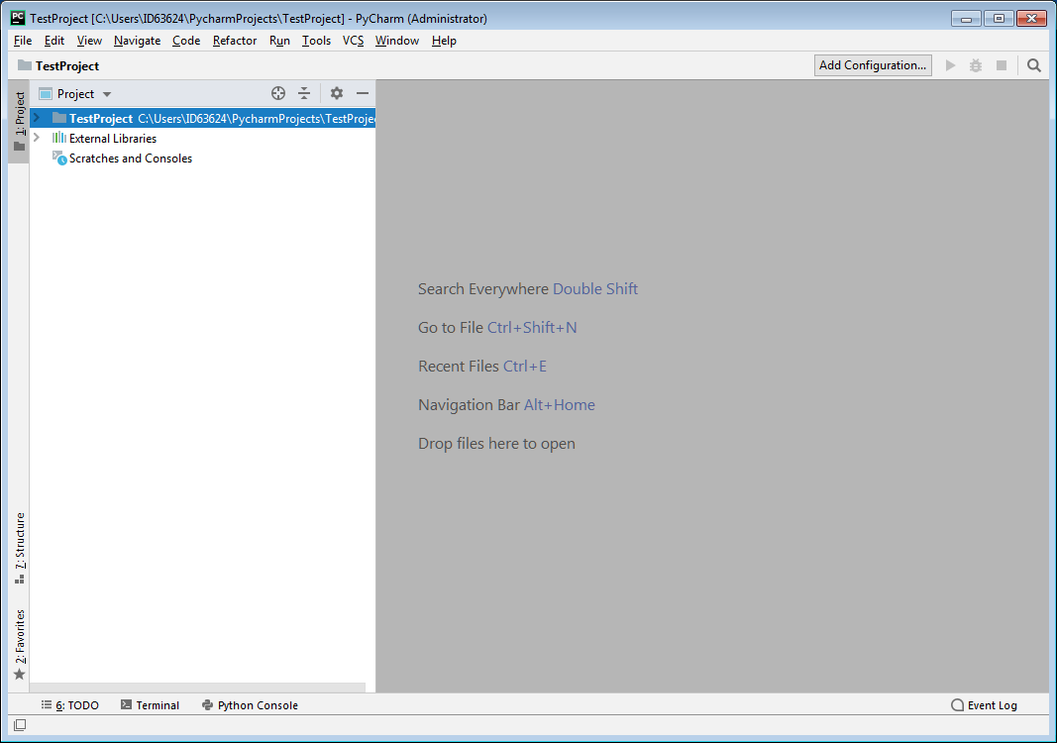

Go to File -> Settings… -> Tools -> **External Tools** and click on **+** icon. Enter the below details in **Create Tool** popup screen and click on OK button.

**The paths can be different based on where Python is installed in your machine.**

Name: **Robot**

Program: **C:\Users\ID63624\AppData\Local\Programs\Python\Python37\Scripts\robot.exe**

Arguments: **--outputdir $FileDir$\results $FileDir$\$FileName$**

Working directory: **C:\Users\ID63624\AppData\Local\Programs\Python\Python37\Scripts**

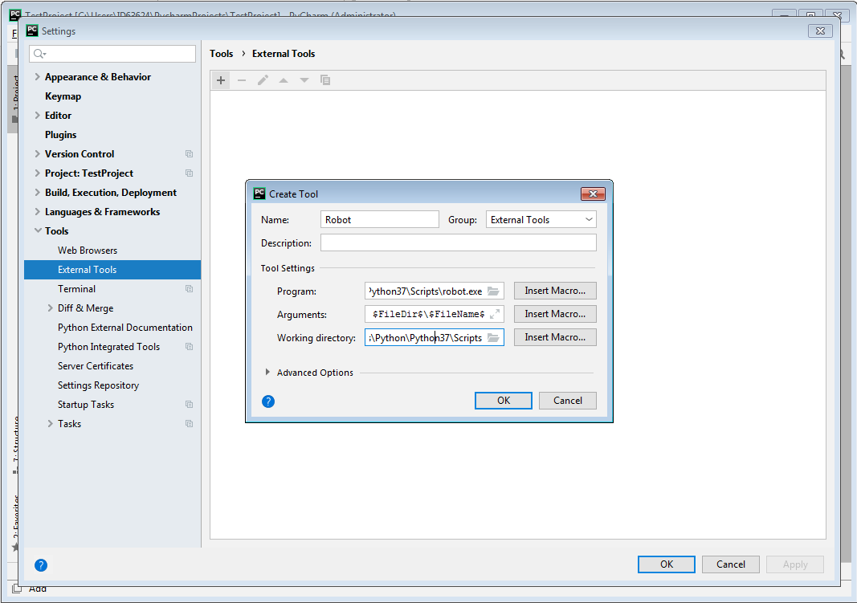

Go to **Plugins** in the same Settings window and search for **Intellibot** and click on Install button to install this plugin. Restart IDE.

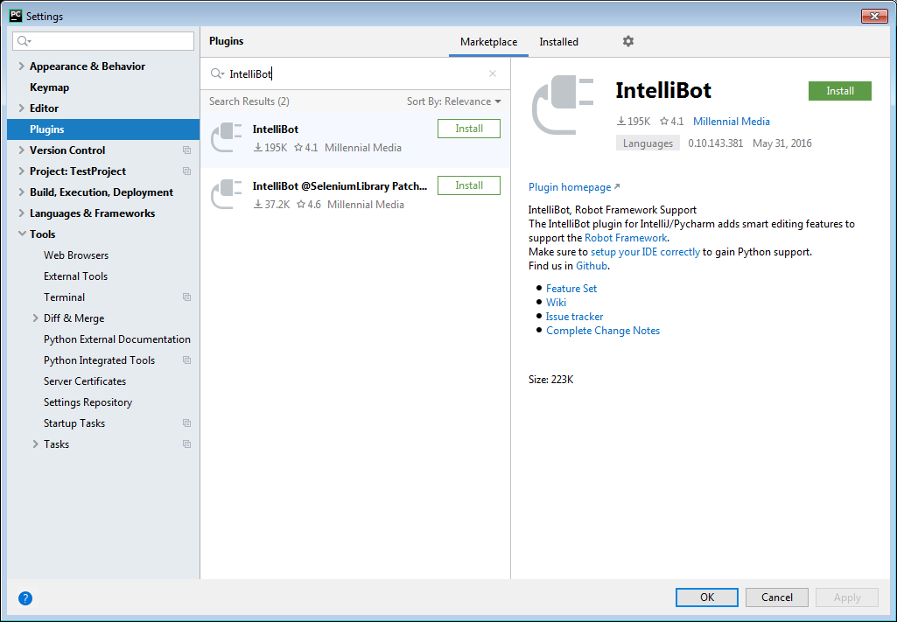

Right click on TestProject, in the cascading menu, select New -> File. Create a test file “**TestFile.robot**”

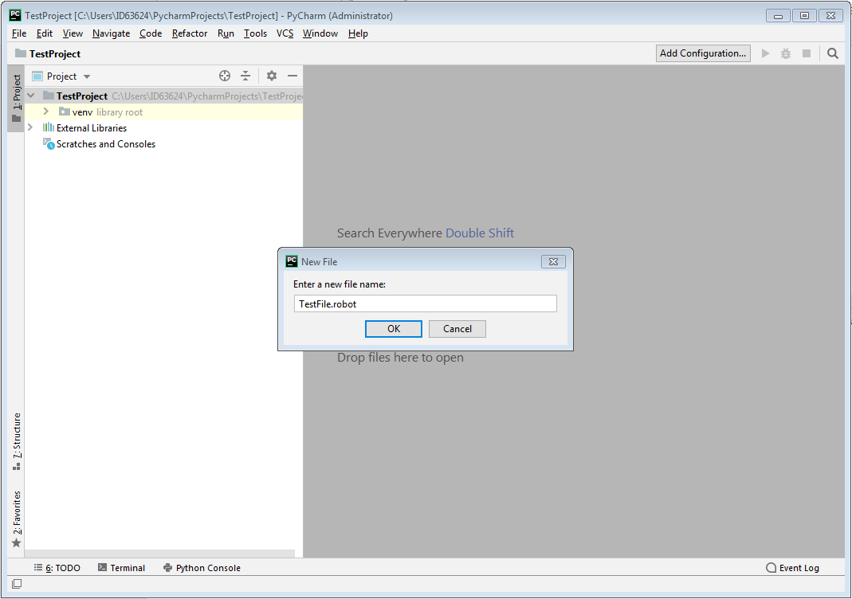

Copy the below file content to TestFile.robot file.



Update the below URL in terms of test environments and user type

https://pasdev1.countrypassport.net/AMPolicyWriter/AMEntryPoint?pageCode=SEARCH&theme=country&appMode=portal&customerID=&sessionInit=XXXXXXX

eINT1: pasint1

eINT2: pasint2

eINT3: pasint3

eINT4: pasint4

eINT5: pasint5

eQA: pasqa1

ePreProd: passupp

XXXXXXX: ID42062 (FR) / ID18237 (UW)

Go to File -> Settings in Pycharm

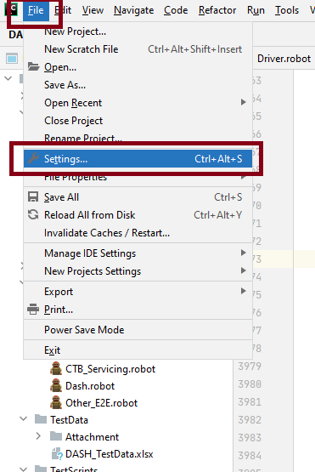

Go to Python Interpreter under Project 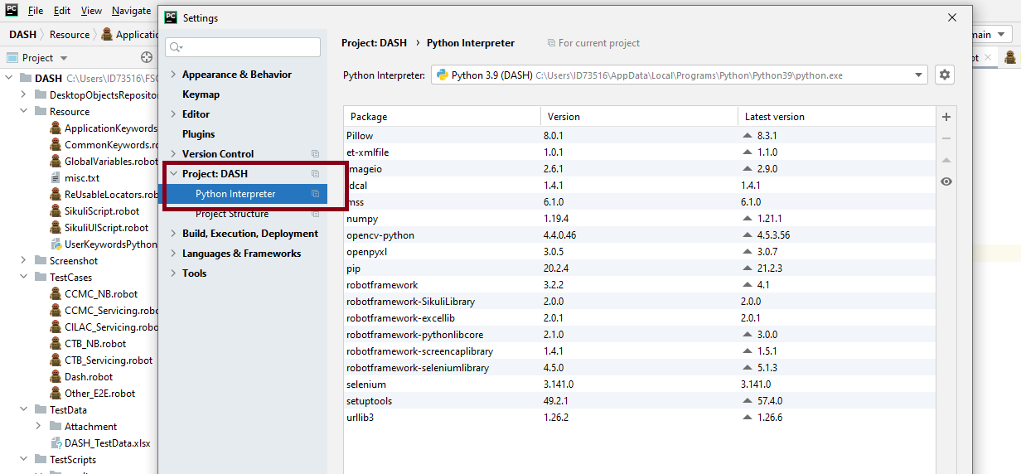

Click on + button and add all the below highlighted libraries.

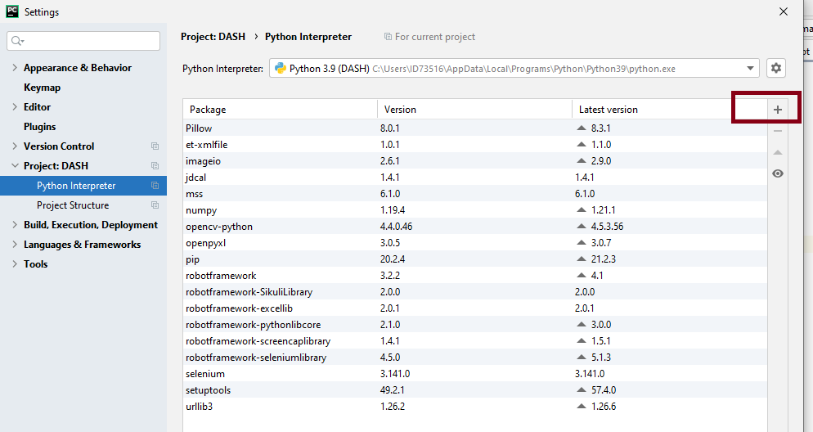

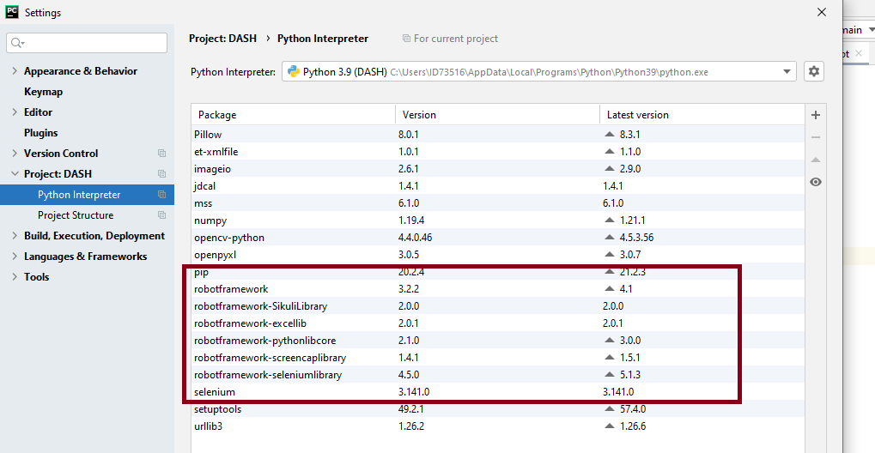

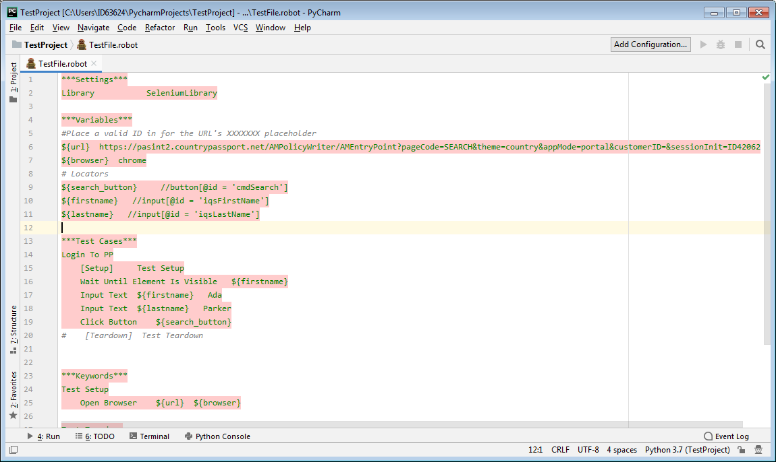

Right click on TestFile.robot ->External Tools ->**Robot**. Click on Robot menu and execute this robot script.

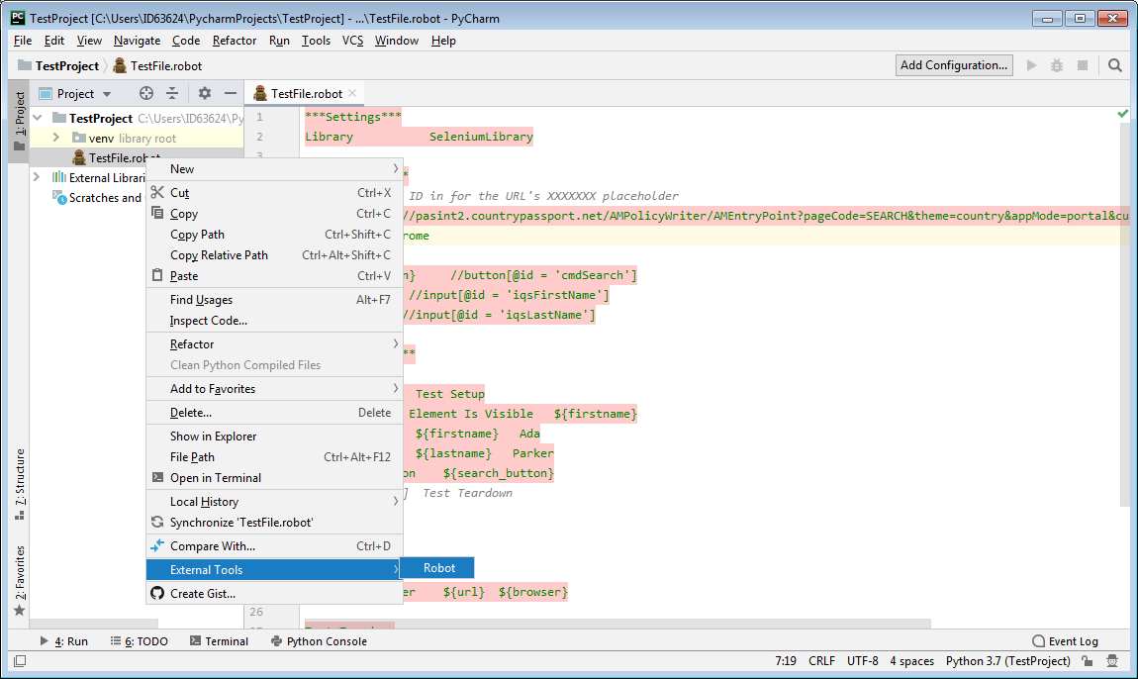

PW Direct Link should be launched and search for a customer. Below is the screen shot of last step for this test file.

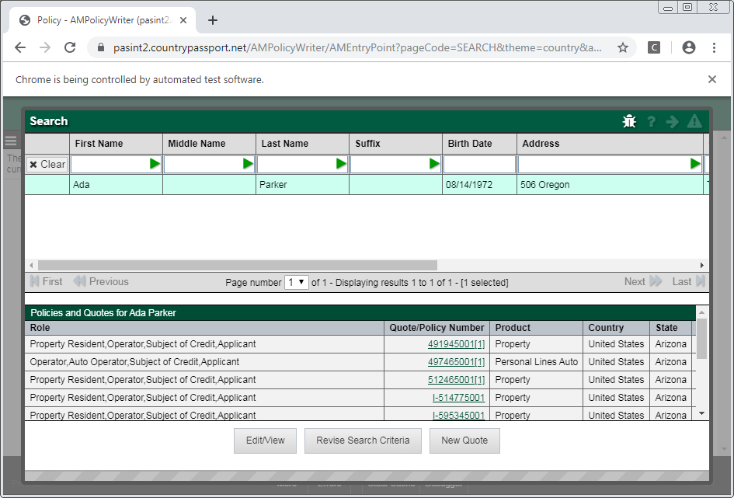

Once the execution is complete, a results folder with log file, output file and report file will be created. Right click on report.html -> **Open in in Brower** -> Chrome.

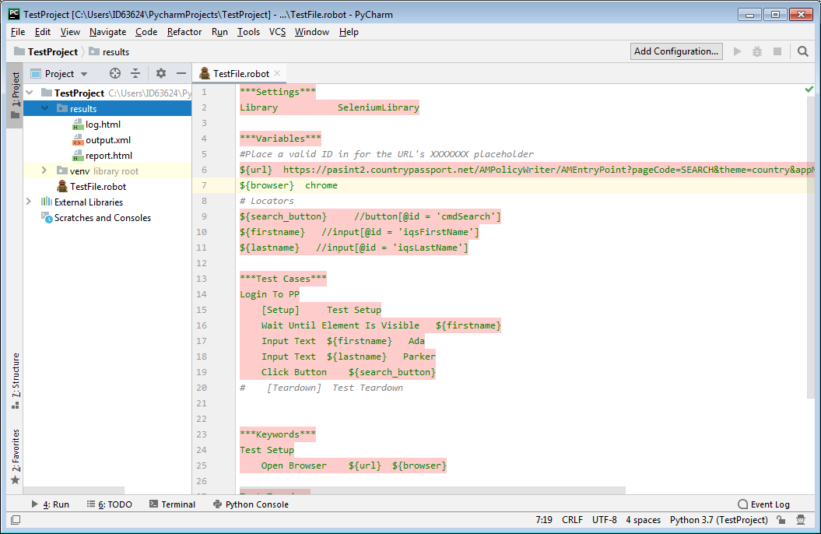

TestFile Report can be displayed with Summary Information, Test Statistics and Test Details information.

